The Value Builder Advantage:

Creating
Successful

Discovery
Meetings

Introduction:
The discovery meeting is a crucial step on the journey to understanding your clients, identifying their needs, and delivering tailored solutions that work. The Value Builder Report serves as a valuable tool in this process, enabling you to uncover vital insights about your clients and their business.
This workbook is your companion to conducting discovery meetings that get results and close deals. It contains a comprehensive agenda to guide you through a 60-minute discovery meeting. The agenda is not merely a script to follow, but a framework to help you engage in meaningful conversations, ask the right questions, and build trust with your clients.
Effective discovery meetings are about asking the right questions and truly understanding your client’s unique challenges, aspirations, and pain points. As a reminder, the discovery meeting should come after your introduction meeting and after your business owner contact has completed their Value Builder Questionnaire.
The goal is simple: to help you build strong and lasting relationships with your clients and provide them with solutions that truly make a difference.
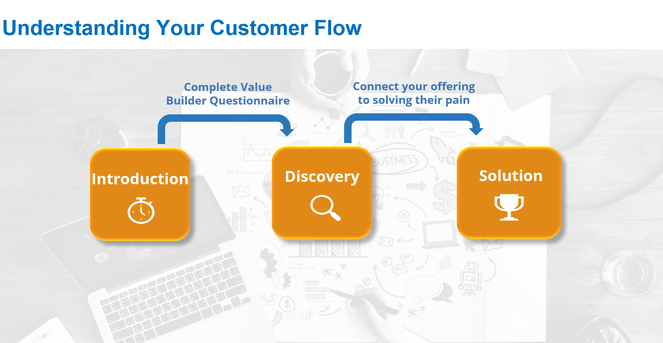

Discovery Meeting Preparation:

During the discovery meeting you’ll want to be engaging, trustworthy and knowledgeable as well as empathetic to an owner’s challenges and pain points. That’s a lot to keep in mind, so preparation for this meeting is crucial. It’s more than simply “knowing your stuff”. It’s about having your prep work complete and having the confidence in yourself to comfortably engage in a two-way discussion and be fully present.

Here are some discovery preparation techniques to keep in mind before your session:

- Download the questions from the completed questionnaire and send a copy to the business owner in advance of the meeting so you can both prepare for the discussion. Ask them to double check that all their info is accurate and to bring any notes to the meeting if they need to adjust.

- Review the questionnaire responses noting anything glaring that stands out. Highlight these points and either clarify up front in the discovery meeting itself or in advance either in email or on a quick pre-discovery phone call.

- Double check the Value Builder Questionnaire to make sure questions 36 and 39 are completed. You’ll need answers to both questions if you’re planning to deliver an estimate of value.
- Question 36 highlights pre-tax profit for the previous three years – it’s marked optional but is important information to have as you get to an estimate of value.
- Question 39 validates the industry your business owner operates in (NAICS code). This information is important for industry benchmarking. You’ll want to check that it’s completed correctly. If you need to check it, you can always use the drill down tools on https://www.naics.com

- If you asked them to complete their income adjustment, make sure this is done. If it’s not, you may want to send it to them as a PDF (Income Adjustment PDF – in Help Centre) and ask them to complete in advance of the meeting.
- Providing a PDF helps to expedite retrieval of info from their accountant or other third party who may be required to provide accurate information.

Discovery Meeting Preparation Document

Instructions:
Create a copy of this page before your discovery meeting. Fill in the blanks prior to the meeting while reviewing their questionnaire results. Use this document to guide you through the discovery meeting with the client to ensure you can easily follow the process and accurately capture important notes.

Client:
Date:

Agenda:
- Introduce (10 min)
- Investigate (35 min)
- Commit (15 min)

Pro Tip! If you find yourself with more than 60 minutes, spend that time in “Investigate” understanding their needs especially in the areas that need improvement.

Introduce (10 minutes):

- Welcome and thank the participants for taking the time to meet.
- Remind them of any key points covered off during your introduction meeting:

Key point # | Notes
Key point 1:
Key point 2:
Key point 3:

- Express appreciation for them completing the Value Builder Questionnaire. Remind them about the power of the Value Builder Questionnaire and how the answers they provided, plus the information you’ve already gathered, will set the stage for your discussion today.
- Check in with them to see if there is anything in the questionnaire they want to adjust. Make the change in real time before you download / review the Value Builder Report as it could impact the score.

Investigate (35 minutes):

- Compliment Their Success (10 minutes):
  - List one or more of the drivers of value from the questionnaire where they are doing well – for example look for one driver where they are achieving great or moderate success.
  - Congratulate them on their achievements.
  - Ask if there were any specific strategies or actions that contributed to their success and note them.

Success Points | Description
Success Point 1:
Success Point 2:
Success Point 3:

Additional Notes:

- Identify Areas Needing Improvement (25 minutes):
  - List one or more drivers of value from the questionnaire that need improvement.
  - Before the meeting, write down the questions you want to ask your client to help them recognize and articulate their challenges.
  - Tie improvements made to the drivers back to their overall goal. For example, “Working on this would help you best position you for exit / grow to the goal you’re striving for / put you amongst best in class / give you more freedom / etc.”

Improvement Area | Description
Improvement Area 1:
Improvement Area 2:
Improvement Area 3:
Improvement Area 4:
Improvement Area 5:

Additional Notes:

Commit (15 minutes):

- Present ONE of Two Commitment Options (10 minutes):
  - Outline a high-level coaching program that addresses their specific needs and challenges and request their commitment for you to build a more comprehensive program based on the meeting’s insights.
  - Offer to put together a package/quote for a tailored solution based on the meeting's insights.

- Set Up Next Meeting + Close (5 minutes):
- Confirm the date, time, and format for the follow-up meeting.
- Summarize the key takeaways from this discovery meeting.
- Express your commitment to helping them achieve their goals.
- Outline the next steps, including follow-up actions and responsibilities.
- Thank your client for their time and engagement.

Additional Meeting Notes:

Post- Discovery Meeting Action Items:

After the discovery meeting, compile and review key notes, ensuring the accuracy of the completed questionnaire. Send a thank-you email expressing gratitude for their engagement and summarizing your commitments and next steps.

Update the Value Builder Report with meeting insights and any adjustments made. Prepare for next steps, whether it's outlining a coaching program or creating a tailored solution and schedule the follow-up meeting. Send promised resources and check for outstanding information.

This approach will further cement your level of trust with the business owner and reinforces your commitment to addressing their needs.

