The Value Builder Advantage:

Crafting Impactful

Minute
Introduction Meetings

Introduction:
- In a fast-paced business world, making the most of a short 15-minute introductory meeting is crucial. Here's a concise guide on how to introduce a potential business owner contact to your business, and the ways you use Value Builder, to build trust and set the stage for your next step – the Discovery Meeting.

Preparation:
- Prior to the meeting, gather essential information about the business owner and their business. Focus on key questions to make the most of your limited time.
- Remember to focus on the four key areas of the introduction meeting (see infographic below):
  - How you introduce yourself and your business
  - The challenges or desired outcomes of the business owner you’re meeting with
  - Effectively introducing Value Builder
  - Your promise – what you’ll do between the intro meeting and your next meeting together the Discovery Meeting
- Successfully navigating each of these key areas keeps engagement up and momentum building as you move from building trust right through building an owner’s excitement for what comes next in your work together.
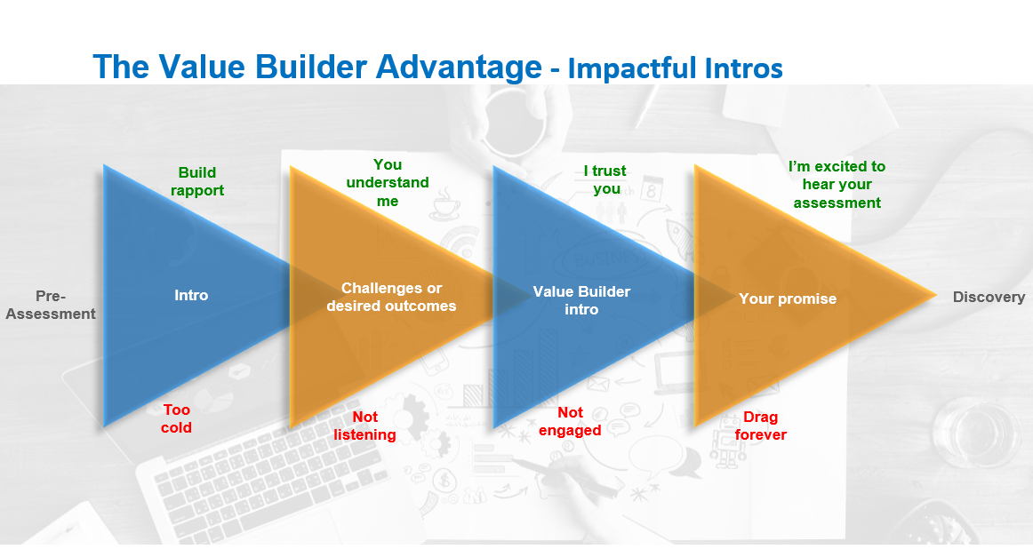

15-Minute Intro Meeting Agenda:
Note: On pages 5-7 you’ll find detailed speaking points for each agenda item. Spend some time with each point and create a talk-track that’s natural to the way you deliver information.

1. Quick Introduction (2 minutes):
- Begin with a warm greeting.
- Briefly introduce yourself and your role.
- Express your interest in learning more about their business.

2. Rapid Needs Assessment (6 minutes):
- Ask specific, mostly open-ended questions to understand their most pressing needs and challenges.
- Connect their concerns to the bigger picture. “What you’re describing sounds like it’s related to challenges with ________”.

3. Value Builder Introduction (3 minutes):
- Mention that the next step is to complete the 15-minute ‘Value Builder Questionnaire’ which will help to clarify and diagnose what’s happening in their business
- Explain that it's a vital assessment tool that provides insights into their business.
- If necessary, explain how Value Builder System helps to increase business value.
- Share a brief success story or testimonial to illustrate its effectiveness whenever possible.

4. Schedule the Discovery Meeting (2 minutes):
- Propose a specific date and time for the Discovery Meeting, preferably within the next few days.
- Reiterate the importance of the questionnaire for the upcoming discussion.

5. Thank You and Wrap Up (2 minutes):
- Express gratitude for their time.
- Confirm the scheduled Discovery Meeting and provide contact details for further inquiries.
- Close the meeting on a positive note.

Pro Tip! If your introduction meeting is 30-minutes Vs 15-minutes long, spend most of your additional time in the Needs Assessment Portion (agenda item 2) and highlighting the benefits of the Value Builder Questionnaire (agenda item 3).
After Meeting Follow-up Actions:
- Send a follow-up email within hours, confirming the Discovery Meeting details.
- Include a link to the Value Builder Questionnaire and clear instructions for completion.
- Specify any materials or information they should prepare for the next meeting.

Key Takeaways:
- In a 15-minute intro meeting, focus on brevity and clarity.
- Highlight the Value Builder Questionnaire’s benefits in a concise manner.
- Schedule the Discovery Meeting promptly.
- Be prepared to answer brief questions.
- Send a follow-up email with relevant details immediately.

With this streamlined approach, you maximize the impact of your 15-minute introductory meeting and set the stage for a productive follow-up Discovery Meeting and advisory relationship that will help the business owner achieve their goals.

Speaking Points for Each Agenda Item:

- Quick Introduction:
- Let them know who you are, and how you work with business owners.
- Set the stage for the meeting by letting them know you’re here to listen, understand their objectives and work together on a customized plan to enhance their business’ value.
- You want them to know early on that you’ve got their back and can guide them to success.
- Mention the Value Builder System as a differentiator.

- Rapid Needs Assessment:
- Here you want to ask them a few key questions to get them talking to you about their business and challenges.
- Using the 80/20 rule you want them talking about 80% of the time and you talking 20% - prompting them as necessary and clarifying points they make.
- Remember to ask open ended questions here. These typically start with “What” and “How” to elicit responses that give you a lot of information. Avoid “Why” questions as this can put your business owner on the defensive.
- Ask about their primary business objectives right now.
- Ask about the biggest challenges, or obstacles, their business is currently facing and how this has impacted their business and if related, to their personal life.
- Ask what they have tried in the past to get past these challenges.
- Ask them if they’ve considered their long-term exit strategy – and if so, what that entails.
- Ask them what sets their business apart from their competitors.
- Ask them how they envision the future of their business in the next 3-5 years.
- You want to come away understanding their current challenges and their long-term goals so that you can tier your solutions with their needs.

- Value Builder Introduction:
- Mention that step 1 is to complete a 15-min assessment called the Value Builder Questionnaire to best diagnose what they’re experiencing. This questionnaire evaluates their business across eight key drivers that significantly impact its value, such as financial performance, growth potential, and customer satisfaction.
- Once they’ve completed the questionnaire, you gain valuable insights into the strengths and weaknesses of the business. This provides a clear snapshot of the business's current value.
- The magic happens when you analyze the results together during a Discovery Meeting. This is where you dive deeper into their questionnaire responses, understand their business objectives, and chart a customized plan to enhance their business's value.
- The goal is to help identify opportunities for growth, streamline operations, and ultimately make their business more attractive to potential buyers, investors, or for their own long-term goals.
- The Value Builder System has a track record of success. Business owners who've followed this path have seen remarkable improvements in profitability, stability, and market position.

Here's why the Value Builder Questionnaire is essential to the process:
- Objective Insights: It provides you with objective, data-driven insights into a business's performance in critical areas.
- Customized Report: After completing the questionnaire, they'll receive a customized report that highlights their business's strengths and areas that need attention.
- Benchmarking: They can see how their business stacks up against industry benchmarks.
- Strategic Planning: It serves as a foundation for your strategic discussions. With the results, you can create a tailored plan to enhance the business's value, whether their goal is to improve profitability, prepare for a sale, or achieve long-term success.
- The Value Builder System has been trusted by a vast community of business owners who have used it to unlock their businesses' full potential.

Advisor Best Practice: Here are four proven ways you can position the Value Builder Questionnaire in your Intro meetings:

- Benchmark Approach
Position the questionnaire as a quick way to understand where their business fares in comparison to others in their industry. In the report there are markers next to each driver that show where their business compares to the industry average.
- Vision Approach
Tie the benefits of fixing a business owner’s pain or problem to their long-term goals. If they want to exit their business in 5 years, for example, you can show how to ensure that’s possible.
- Diagnostic Approach
Position the questionnaire to understand if their company could use your help. Say something like, "There might be something else going on here” and offer to help them uncover hidden issues.
- Discovery Approach
Great for business owners who don’t have a sense of the overall health of their business. Position the questionnaire as exploring together to find out which areas are strong and which areas are opportunities to improve.

- Schedule the Discovery Meeting
- This meeting will give you the opportunity to sit down together and delve deep into the questionnaire results.
- Think of it as a strategic session dedicated solely to their business. You’ll go over the strengths and pinpoint areas that might need a bit more attention. It's a critical step in the journey to maximize their business's value.
- Mention their insights from the questionnaire are the key to your work together, and that the Discovery Meeting is where you’ll both turn those insights into actionable strategies.
- Reinforce that you’re here to support them every step of the way.

- Thank You and Wrap Up
- Remind them, this isn't just about numbers; it's about realizing their vision and achieving their goals. You’re always there to provide guidance, support, and expertise every step of the way.
- Between now and your next meeting, have them dedicate time to complete the questionnaire thoroughly. Their insights will be the foundation of your strategic discussions.
- Remind them that if any questions or ideas come up, they should reach out. This partnership is about collaboration and achieving success together.
- Reinforce that their initial questionnaire doesn’t have to be completed perfectly. If there are sections that they don’t confidently know the answers to, let them know that this is perfectly fine, and you will help them fill in any blanks.
- Signoff noting that you look forward to the next meeting, where you'll embark on this exciting journey toward maximizing their business's value. Until then, remind them to stay focused on the goals you discussed.

