Session 1: Target Market

It’s so important to niche down and select a target to make your messaging efforts as focused as possible. Here are the two whitepapers related to company size as well as the owner’s psychographics discussed today. You should also define by business stage etc. as listed below.
- Hiding in Plain Sight - Chipmunks / Zebras / Whales
- Entrepreneur’s Trusted Advisor – Mountain Climbers / Freedom Fighters / Craftsperson

Industry Targets - NAICS Codes are a good place to start when you’re niching down, but consider in which industry your expertise shines
- NAICS.com
- NAICS codes to SIC code

What size of company do you intend to target (e.g. Number of employees, revenue, enterprise value)?

What industries do you/will you target? (specify NAICS code)

What business life stage and/or demographic will you target?

What personal traits will you look for in a potential business owner client?

What action will you take in the next 7 days to zero in on your target?

How many business owners you are connected to right now that fit this target audience?

Session 2: Unique Positioning

We’re now going to challenge you to pinpoint the problems/pains that will resonate most with your intended target. Preparing a positioning statement will guide your messaging to ensure synergy, focus your resources and help you stand out in the noise.
Step 1: Confirm the industry (or unique identifier) that you chose to target
Industry niche(s) you want to target:

Step 2: Identify The Problem the Customer Faces
Identify the top problems your niche faces:

Step 3: Link the Problem to a Value Driver
Write how your problem impacts each driver then select the one that is most impacted. For examples of common Driver problems see the whitepaper ‘Struggle to Strength’

- Financial Performance

- Growth Potential

- The Switzerland Structure

- The Valuation Teeter Totter

- Recurring Revenue

- Monopoly Control

- Customer Satisfaction

- Hub and Spoke

Step 4: Show the Emotional Impact of the Problem
Write out the owner’s top 3 most common emotional regrets/pains:

Step 5: Craft Your Positioning Statement
Position yourself as an expert in solving the problem:

Step 6: Provide Proof
Use a testimonial to build confidence.
Top 3 testimonials:

Bringing it all together:
Copy and paste in the top options from each step to pull together your Value Builder positioning statement:

Step 1:

Step 2:

Step 3:

Step 4:

Step 5:

Step 6:

Now combine all the elements together and integrate the sentences as if it were in an email. It should flow smoothly. (See email example on next page)

You can leverage your completed positioning statement with external teams (web designers, marketing or virtual assistant etc.) to ensure that everyone is clear on your direction. You can also use it directly in AI tools like ChatGPT to generate additional ideas for headlines, or emails etc.

There are lots of online resources and it’s simple to use ChatGPT - here are some tips.

Email outreach example:

Subject: Why Patient Retention is Important
Hi Sandra,
Patient retention is an issue for many dental practices – dentists retain less than 41% of the new patients.
As you know, at some point you need to think about selling your practice or passing it on. Like most dentists, you probably want to maximize the value in your practice, and of the biggest characteristics of a valuable dental practice is one with a high number of repeat consistent customers. This is a concept referred to as Recurring Revenue – It is how much revenue you can consistently get from a customer - in your case a patient. What I hear many dentists talk about is not getting top dollar on the sale of their practice.
After years of building up their practice, they realized that small things they didn't think about before really dragged down their value and they ended up with less than they wanted. This recurring revenue is only one example, but there are many more.
I have developed a proven method to increase the retention rate by 25% in a dental practice. This system helps other dentists spend less on new patient marketing costs, increase patient spend per visit and increase the overall value of their practice.
The concept of Recurring Revenue is one of 8 key drivers that help business owners understand how a buyer will evaluate the value of the business. I have a questionnaire I use to determine the value of any dental practice; would you like to see how your practice stacks up to other practices?
Sincerely,
Alex Stapleton

Session 3: Inbound and Outbound Efforts

Plan for inbound but focus on outbound to ensure success. Don't wait for a perfect website or LinkedIn profile before starting outbound. You can tweak your LinkedIn profile but get proactive to generate personal conversations to feed your funnel.

LinkedIn Suggestions you could implement now – Learning Video
- Ensure your picture stands out
- Effective Headline
- Taglines and company info to your cover photo (background)
- About Section should describe how you help your ideal client
- Include awards, key outcomes etc in Experience Section
- Make use of the Feature section to highlight key projects etc

Outbound

Who can you reach out to who’s either a warm contact, past client, or potential referral partner to connect with?

Pick 2 key communication channels you’ll focus on

*Aim to get 5 Questionnaires (any type) completed in your first 3-6 months.

Email | Social | Phone
Utilize Nurture Cycle to share ongoing drip marketing | Leverage your connections on LinkedIn and zero in on your target | Reach out to warm contacts with personalized messaging
Use SmartFlows for sub segments of your contact list for more specific content | Filter using criteria that you outlined in your niching & target exercise | Sharing insights on topics that would be relevant to them
Connect with prospects direct emails to engage and get the 10 min conversation | Spark conversation with shared interest using the recommended script | Offering a 10 min chat – where you’ll see where they are in their business journey

For example, if you made 5 phone calls per day, and 5 LinkedIn connections per day, over 1 month (approx. 20 business days) that would be 100 phone calls and 100 LinkedIn connections. Could you get 10% (20 owners) to meet with you?
The Simple Message Formula
- Opener (Personalized)
- Tie it to why you’re connecting
- Share insights on why they would want to connect with you
- Add a question or closing statement

Put together an example of this written in your own style

Session 4: Choosing SmartContent

Value Builder's SmartContent is centered around our eBooks, which serve as the foundation for key conceptual ideas. These resources provide readily available materials to help you effectively nurture your target audience.

To get started, your Positioning Statement exercise can guide your selection of the eBooks most relevant to the challenges and drivers you identified. We recommend focusing on a few core eBooks for your initial campaigns and adding variety from there.

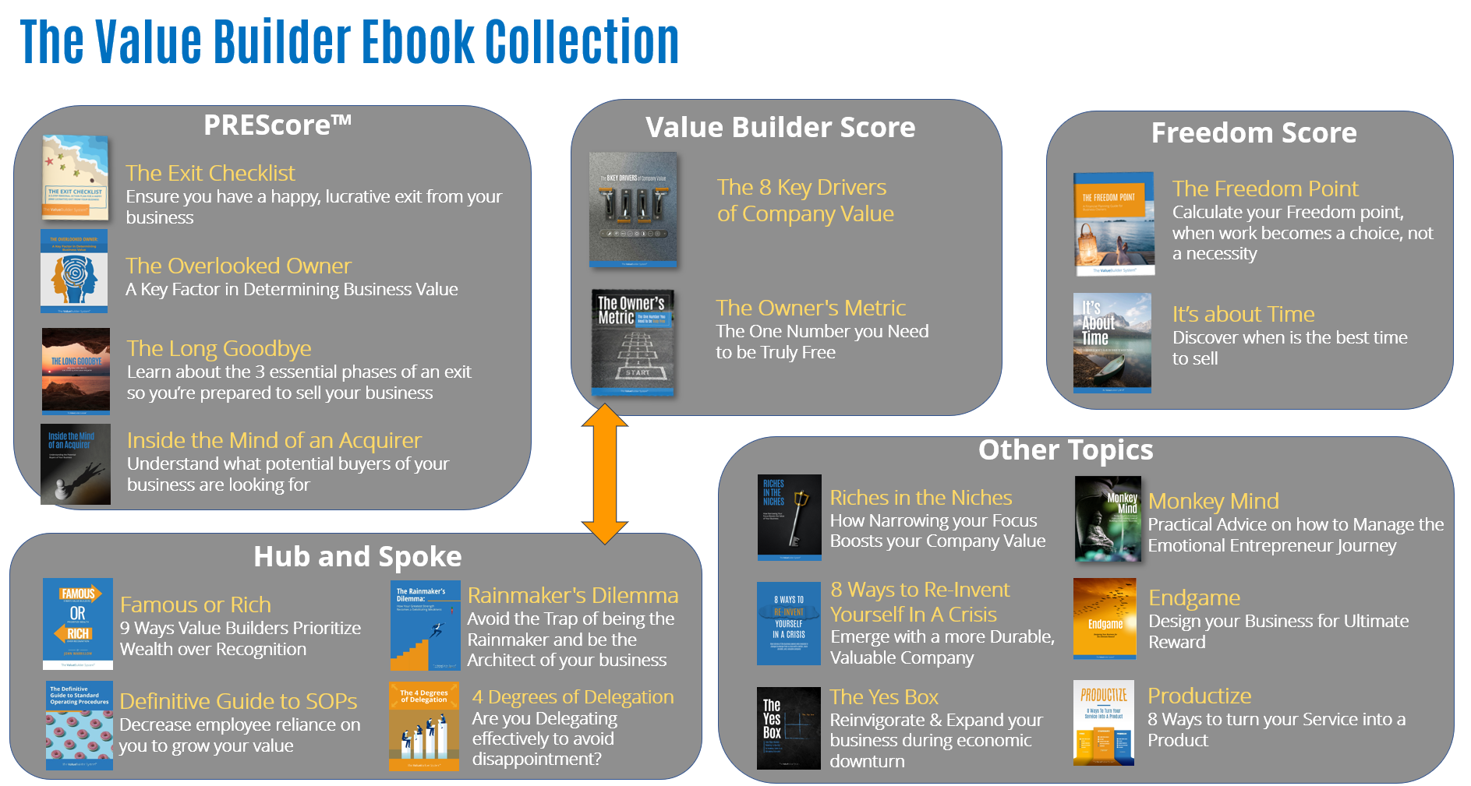

Each ebook has its complement of assets to put together a synergistic campaign
- Lead magnet link
- Email template examples
- Presentation Decks
- Related articles
Based on the plans you devised in Session 3, you can utilize those communication channels with the content you selected here.

Add the Key Driver(s) and your specific uses for each eBook you want to leverage:

EBOOKS
eBook Title | Key Driver(s) | How you Intend to Use*
The 8 Key Drivers of Company Value
The Owner’s Metric
The Exit Checklist
The Overlooked Owner
The Freedom Point
The Endgame
The Rainmakers Dilemma
The 4 Degrees of Delegation
The Definitive Guide to SOPs
The Yes Box
Monkey Mind
Productize
Other…
Other…

TIPS:

You can explore more about SmartContent by clicking the orange tutorials button the right side of the page in the Value Builder Portal.

Posting an eBook on social media:
- Choose your eBook from Settings > Lead Magnets
- Configure your auto-response and copy the link
- Find the social media content for your eBook in Marketing Assets
- Decide which caption and/or visual you would like to use or create your own
- Decide which platform(s) you will use i.e.- LinkedIn, Facebook etc.
- Create and post your eBook (you can leave the eBook link in the comments)
- Monitor and engage in discussions with interested prospects

Email a targeted partner, contact, or list:
- Find the associated eBook email template in Settings >Templates
- Convert and modify the email template for your target audience
- Send your email to a one intended strategic partner, contact, or a list
- You can send list emails via Contacts

Session 5: Bringing it together
90-Day Strategy
What key goals do you plan to achieve in the next 90 days to improve your practice?

30-Day Action Plan
What actions will you take in the next month?

Action Item | Who | When

What are your biggest takeaways from the course?

